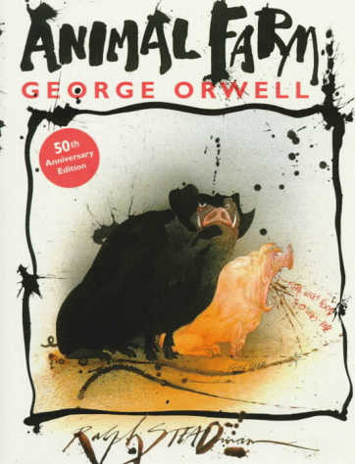
AV: Marcus Stenberg Ribeiro
Animal Farm

On a cold winter night a pig, named the old Major or the Willington Beauty as he was called in his youth, announced that he had had a strange dream last night, and that anyone that would like to
hear it should come to the barn this evening. Since the old Major was very respected by most of the animals they thought that it would be worthwhile to lose an hour of sleep. When they arrived, Old Major produced a long, inspiring speech about a farm driven for animals, by animals. A utopia with food, three-hour-workday and equality to all. Or more specifically for everyone standing on four legs, or with wings. This was the core of Animalism, which can be reduced to “Four legs good, two legs bad”. When the downtrodden beasts of Manor Farm oust their drunken human master and take over management of the land, all are awash in collectivist zeal. Everyone willingly works overtime, productivity soars, and for one brief, glorious season, every belly is full. The animals Seven Commandments are painted in big white letters on the barn. All animals are equal. No animal shall drink alcohol, wear clothes, sleep in a bed, or kill a fellow four-footed creature. Those that go upon four legs or wings are friends and the two-legged are, by definition, the enemy. Too soon, however, the pigs, which have styled themselves leaders by virtue of their intelligence, succumb to the temptations of privilege and power. While this swinish rotherhood sells out the revolution, cynically editing the Seven Commandments to excuse their violence and greed, the common animals are once again left hungry and exhausted, no better off than in the days when humans ran the farm.

Even though the book is only around 100 pages long, it is very good and really shows how a society can go from freedom to suppression. The writer George Orwell has taken the main characters of the Soviet Union and replaced their names, and I feel that the leader of the pigs, Napoleon, represents Stalin because of the way he clears out his fellow revolutionary leaders and declares them to be traitors. His main enemy, Snowball, is a real communist that seeks a classless society with justice for all. The character of Snowball is in my opinion the most important of the book. He is full of good intent; he wants to start classes for the other animals to elevate their understanding of the world. He is also a careless and unrealistic character. What Orwell is saying here is that intent without action is useless. A person who cares about injustice and can't do anything about it is no better than a person who doesn't give it a moment's thought. This farm, much like the Soviet Union, would have worked if man, or in this case pigs, had no greed. If Snowball had been the leader the utopia they sought surely would come true. I can really recognize the way they took a once noble way of thinking and twisted it to fit their needs. It the same way people always do, you twist the truth until it fits you. Although the truth may vary, this still is a fact. And the way the animals were convinced that even though they worked hard, things were much better than before. And since a fellow comrade, on the behalf of the Leader even, said it then it must be true.
I can recognize many actual people, or groups of people, in the book, aside from Stalin and his communist party. Moses the crow who tells the overworked animals that their afterlives will be bliss represents the church. Benjamin the wise, but silent donkey is the silent group of intellectuals who could see what was going on, but did nothing to save themselves. And Squealer, the government publicist talking in fanciful but meaningless figures. This one I identify with Goring, Hitler’s publicist. This is the man that uttered the now widely known sentence “If you repeat a lie a thousand times, it becomes the truth” Strange that what Orwell wrote about the Russian revolution applies to almost any third world country today.

AV: Marcus Stenberg Ribeiro

